# Exercise: Source Control Systems

# Stage 0 – Create Repository

A **single** team member must create a repository for your project, where everyone will contribute. Everyone else **clones the repo** and commits to it. All team members should be added as collaborators.

To **add collaborators**, open the repository on GitHub, and go to **Settings**:

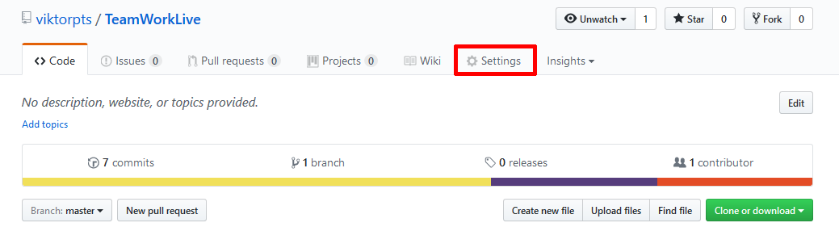

Select **Collaborators** and send an invitation to your teammates:

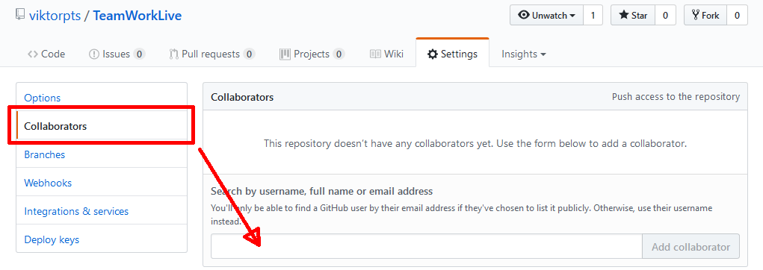

Once they respond to your invitation, they may commit changes to the repo.

**Checkout** the newly created repository using your favorite method (bash, GUI, IDE plugin) and add the files from folder **0. Initial** to it. **Commit** and **push** the files. Your repository is ready to be **cloned** by all team members and work may begin on the rest of the tasks.

|  |
| --- |
| **Each task should be assigned to a different team member. Work should begin by pulling the changes from a previous completed stage. Once you’ve pulled a ready stage, do not pull again until you task is completed. Changes should be committed in the order in which the tasks are listed. You should not begin working on the next stage, before all task from the current stage are finished and conflicts have been resolved. Once this is done, everyone pulls the changes and work on the next stage may start.** |

For example, you’re at Stage 2. All tasks from Stage 1 are complete, everyone pulls from the master. There are three tasks in stage 2 – Task 2-1, 2-2 and 2-3. Work on all tasks **simultaneously** and push changes in the correct order. After everything is committed and conflicts are resolved, this stage is finished – everyone pulls from the master and work may begin on tasks from stage 3.